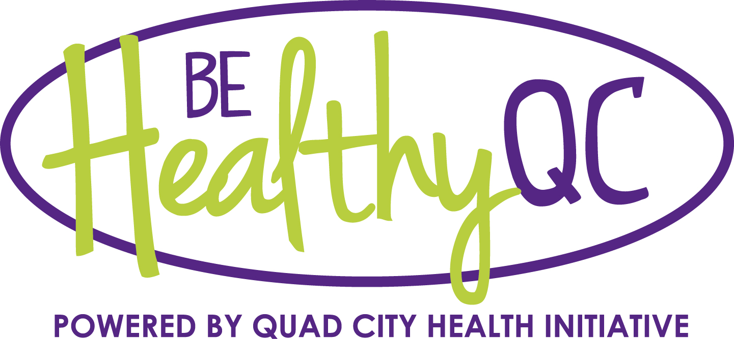
XXXXXX Dist. #XX Wellness Team
MEETING AGENDA
Monday, XXXXXXX, 3:45 p.m. in the 3rd Floor Conf. Room, XXXXXXXX

Members present:

- Introductions

- PICH Overview – Handout

- Annotated version of Local School Wellness Policy Implementation under the Healthy, Hunger-Free Kids Act “Final rule.”
- Present Moline Wellness Policy

- Copy of “Alliance for a Healthier Generation Model Wellness Policy”

- Local school wellness assessment instrument – Where are we in getting this completed at all buildings?

- “Healthier US School Challenge” overview and discussion

- Next meeting date/time

- Suggested Agenda Items

